HOTEL BOOKINGS
Exploratory Data Analysis Report

A statistical and visual investigation of booking behaviour,
pricing, and cancellation patterns across City and Resort hotels
Dataset: hotel_bookings_cleaned.csv
Records: 87,203 | Fields: 36
Prepared: August 2026

Executive Summary
This report presents a comprehensive exploratory data analysis (EDA) of 87,203 hotel booking records spanning City and Resort properties. The dataset, already cleaned and containing no missing values across its 36 fields, was examined through descriptive statistics, univariate and bivariate visualisations, correlation analysis, and formal hypothesis testing to surface the key drivers of pricing and cancellation behaviour.
Key Takeaways
City Hotels command a higher average daily rate (ADR ≈ 110.79) than Resort Hotels (ADR ≈ 97.28), and this difference is statistically significant (t-test, p < 0.001). Cancellations are strongly tied to booking channel and lead time: cancelled bookings carry a mean lead time of 103.22 days versus 69.06 days for completed stays, and hotel type is significantly associated with cancellation outcome (Chi-square test, p < 0.001). Overall, 28.0% of all bookings in the dataset were cancelled, with the City Hotel showing a materially higher cancellation rate (30.1%) than the Resort Hotel (23.5%).

Table of Contents

1. Introduction & Dataset Overview
The analysis is based on a cleaned hotel booking dataset containing 87,203 records and 36 columns, covering booking, guest, and pricing attributes for two hotel types: City Hotel and Resort Hotel. The objective of this EDA is to understand the distribution of key numeric variables, profile categorical booking attributes, examine relationships between pricing and other features, and statistically test two specific hypotheses about pricing and cancellation behaviour.

1.1 Data Quality
A completeness check across all 36 columns confirmed zero missing values in the dataset, consistent with it having already been through a cleaning pipeline prior to this analysis. No imputation or row removal was required before proceeding with the exploratory work below.

1.2 Field Groups
- Booking attributes: hotel, lead_time, arrival_date_*, deposit_type, customer_type, market_segment, distribution_channel
- Guest attributes: adults, children, babies, total_guests, is_family, country
- Stay attributes: stays_in_weekend_nights, stays_in_week_nights, total_nights, reserved_room_type, assigned_room_type
- Commercial attributes: adr (average daily rate), agent, booking_changes, days_in_waiting_list
- Outcome attributes: is_canceled, booking_status, reservation_status, reservation_status_date

2. Descriptive Statistics
Central tendency and dispersion measures were computed for the four numeric variables most relevant to guest behaviour and pricing: Average Daily Rate (ADR), Lead Time, Total Guests, and Total Nights. These summaries form the statistical baseline for the visual analysis that follows.
Metric | ADR | Lead Time | Total Guests | Total Nights
Mean | 105.53 | 78.46 | 2.03 | 3.58
Median | 98.25 | 49.00 | 2.00 | 3.00
Std. Deviation | 49.03 | 81.06 | 0.79 | 2.45
Skewness | 0.51 | 1.10 | 10.54 | 1.38
Minimum | 0 | 0 | 1 | 0
Maximum | 227 | 296 | 55 | 14
Table 2.1 — Summary statistics for key numeric variables
The mean ADR of 105.53 sits above the median of 98.25, and a positive skew of 0.51 confirms a right-tailed distribution, i.e. a subset of premium-priced bookings pulls the average upward. Lead Time shows a much stronger right skew (1.10), reflecting a large group of short-notice bookings alongside a long tail of bookings made many months in advance. Total Guests is heavily skewed (10.54) due to a small number of large group bookings against a dominant baseline of one- and two-guest stays.

3. Univariate Distribution Analysis
Histograms were used to examine the shape, spread, and central tendency of the dataset's principal continuous variables.

3.1 Average Daily Rate (ADR)
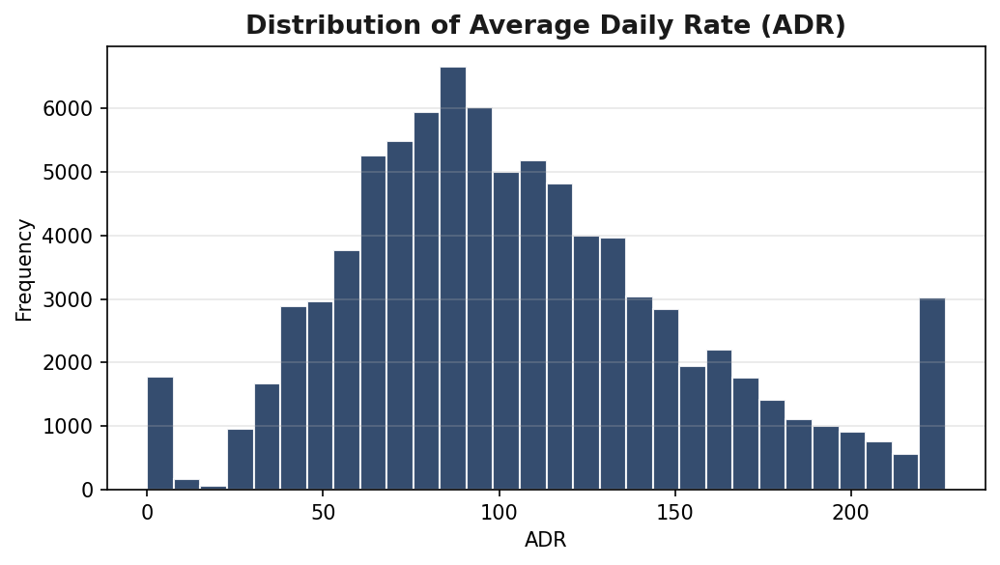
Figure 3.1 — Distribution of Average Daily Rate
ADR is unimodal and right-skewed, concentrated between roughly 57 and 155, with a mean of 105.53 and a standard deviation of 49.03. The distribution's shape is consistent with a small share of premium or last-minute high-rate bookings, while the bulk of stays are priced in the mid-range.

3.2 Lead Time
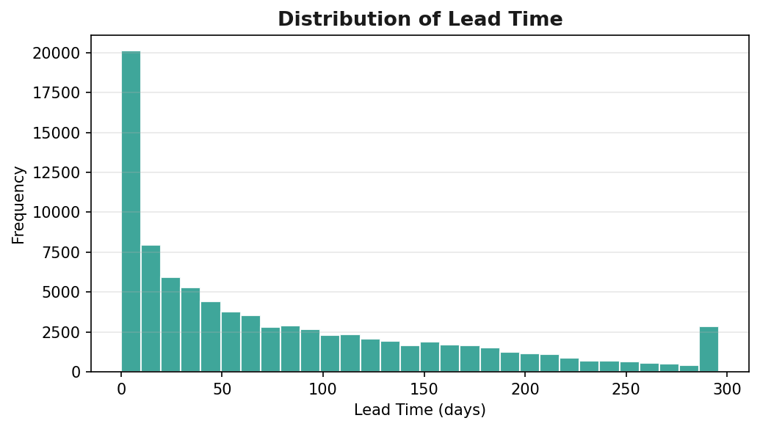
Figure 3.2 — Distribution of Lead Time
Lead time is strongly right-skewed: most guests book within roughly 49 days of arrival (the median), but a meaningful tail of bookings is made 160+ days in advance. This pattern is typical of a mixed customer base combining spontaneous travellers with early-planning guests and travel agents.

3.3 Total Guests
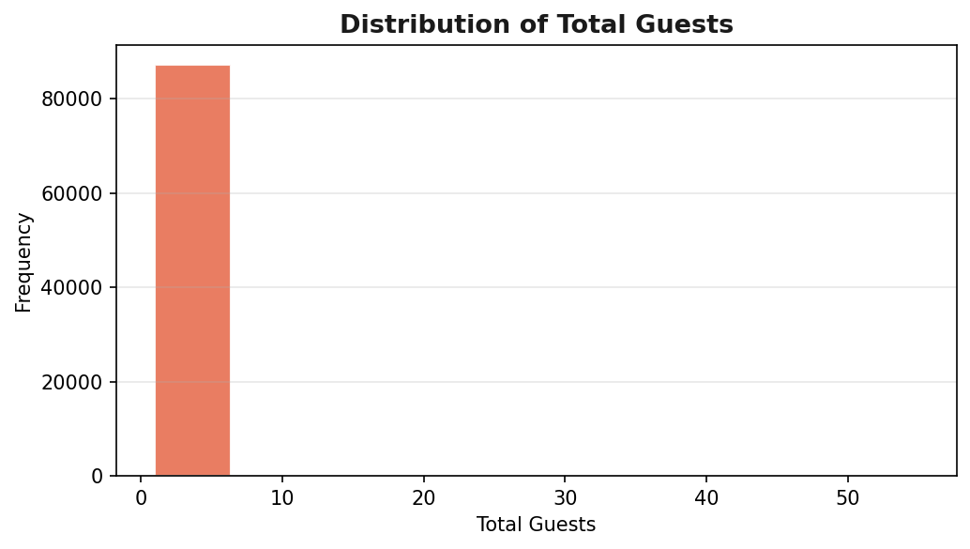
Figure 3.3 — Distribution of Total Guests
The overwhelming majority of bookings are for one or two guests, consistent with a mean of 2.03. The very high skew (10.54) is driven by a small number of large-party bookings that appear as isolated bars far to the right of the main distribution.

3.4 Total Nights
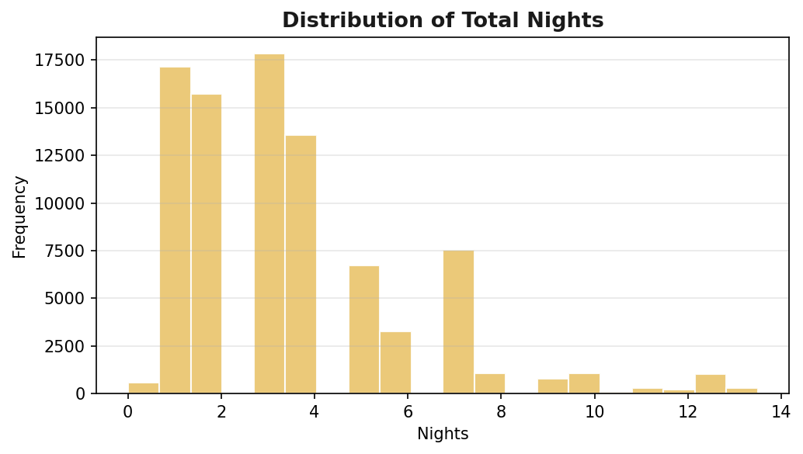
Figure 3.4 — Distribution of Total Nights
Stay length peaks around 3-4 nights and tapers off steadily, reflecting typical short-break and standard-week travel patterns rather than extended stays.

4. Categorical Analysis
The categorical fields were profiled to understand the composition of the booking base across hotel type, cancellation status, customer segment, and channel.

4.1 Hotel Type Distribution
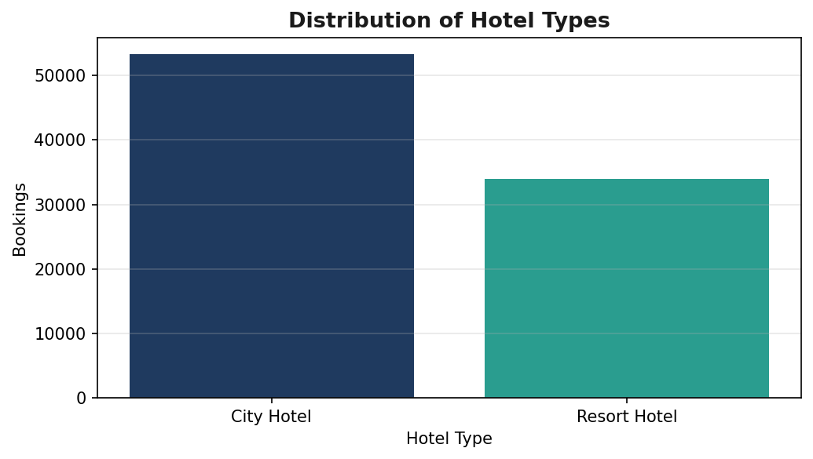
Figure 4.1 — Distribution of Hotel Types
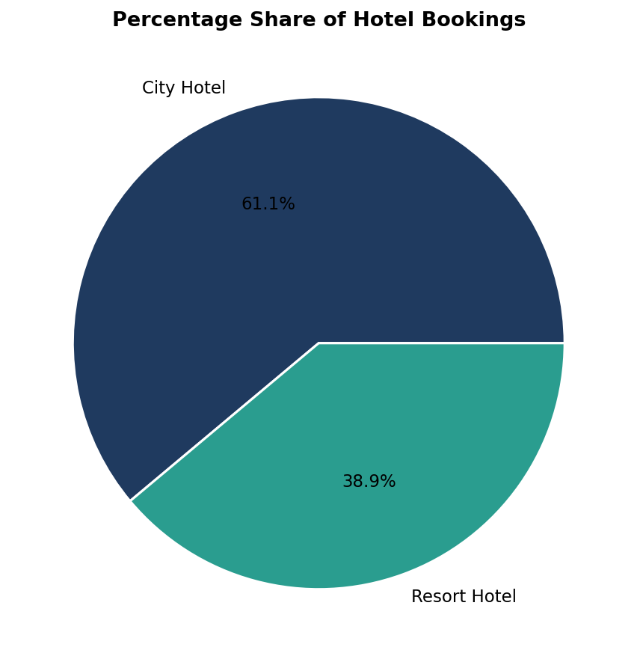
Figure 4.2 — Percentage Share of Hotel Bookings
City Hotel accounts for 53,272 bookings (61.1%) versus 33,931 (38.9%) for Resort Hotel, making City Hotel the dominant property type in this dataset.

4.2 Booking Status
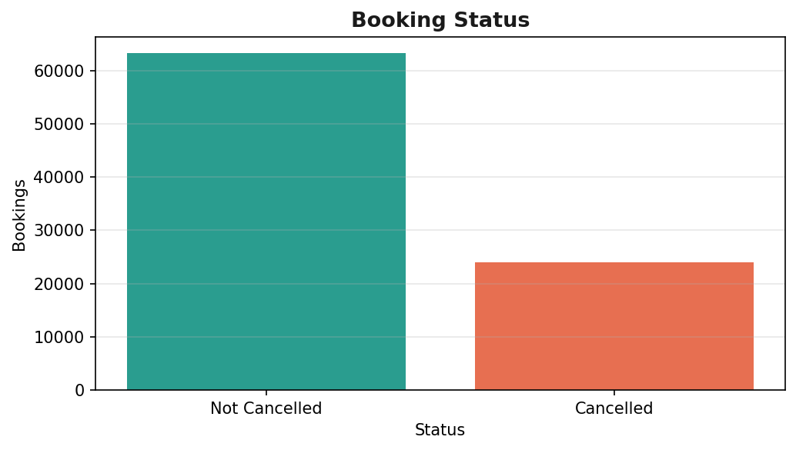
Figure 4.3 — Booking Status
27.5% of all bookings were cancelled (24,008 of 87,203), leaving 72.5% completed. This cancellation rate is explored further, split by hotel type, in Section 5.7.

4.3 Customer Type
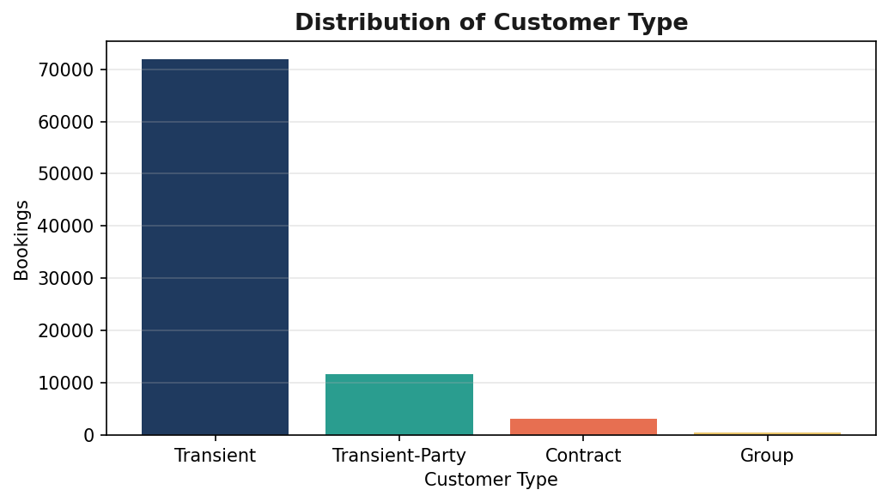
Figure 4.4 — Distribution of Customer Type
"Transient" guests (individual, non-grouped bookings) form the clear majority of the customer base, with Transient-Party, Contract, and Group segments each contributing a smaller share. This composition points to a customer base dominated by independent leisure and business travellers rather than block or group bookings.

4.4 Market Segment
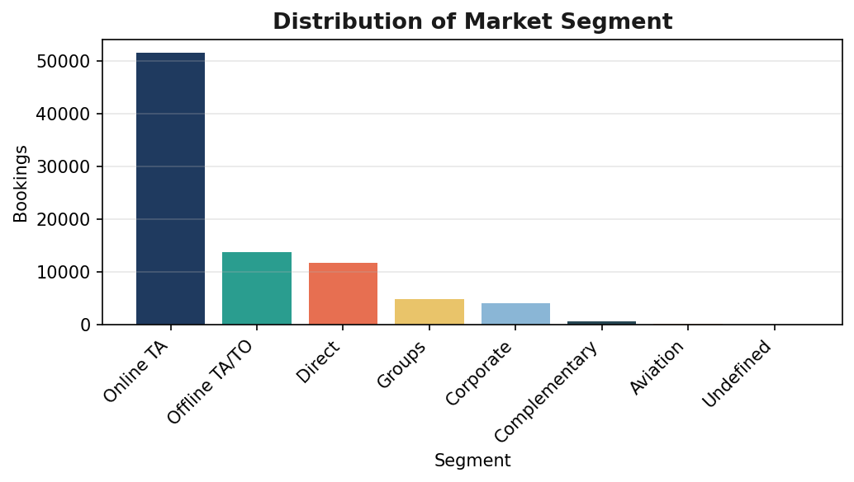
Figure 4.5 — Distribution of Market Segment
Online Travel Agents (Online TA) represent the largest acquisition channel, ahead of Offline TA/TO and Direct bookings, underscoring the importance of OTA partnerships to overall booking volume.

4.5 Meal Preference
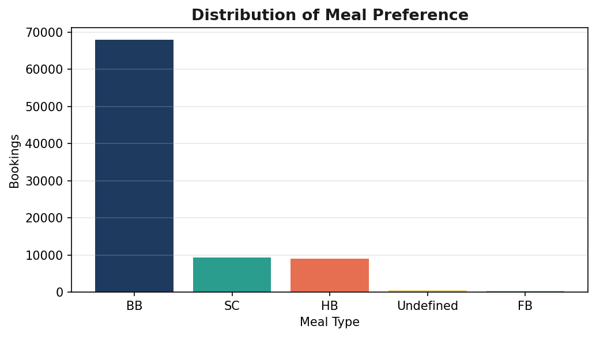
Figure 4.6 — Distribution of Meal Preference
Bed & Breakfast (BB) is the dominant meal plan chosen by guests, consistent with typical hospitality-industry booking patterns where full-board and self-catering options are comparatively niche.

4.6 Deposit Type
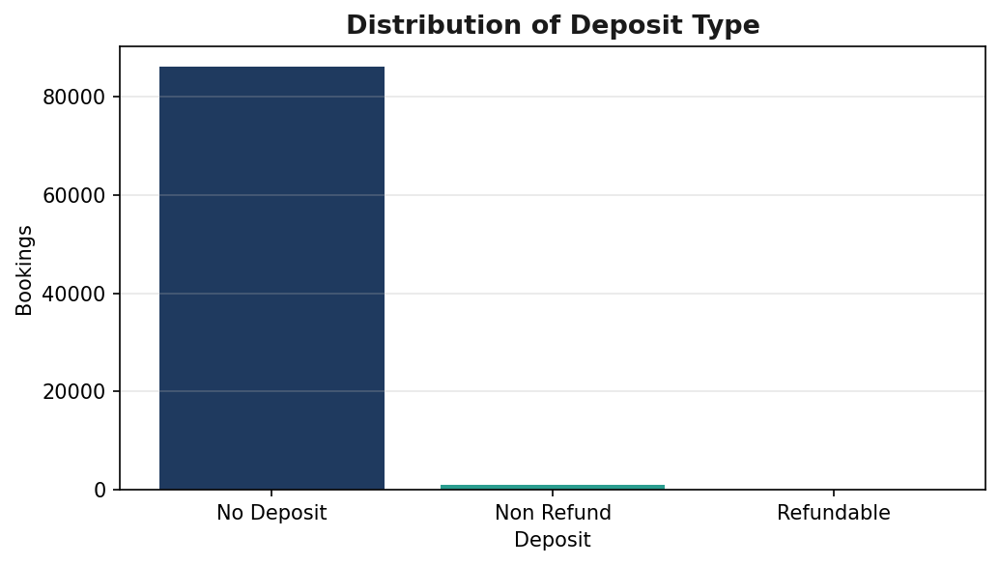
Figure 4.7 — Distribution of Deposit Type
The vast majority of bookings require no deposit, with refundable and non-refundable deposit types making up a small minority — a factor worth cross-referencing against cancellation behaviour in future analysis.

4.7 Reserved Room Type
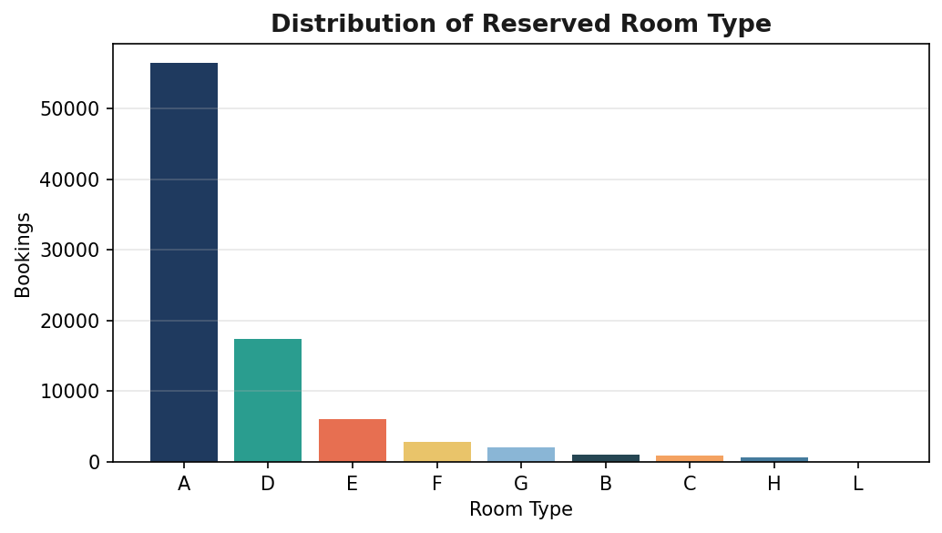
Figure 4.8 — Distribution of Reserved Room Type
Room type "A" is booked far more frequently than any other category, suggesting it represents the standard/default room class offered across both hotel types.

4.8 Top 10 Countries
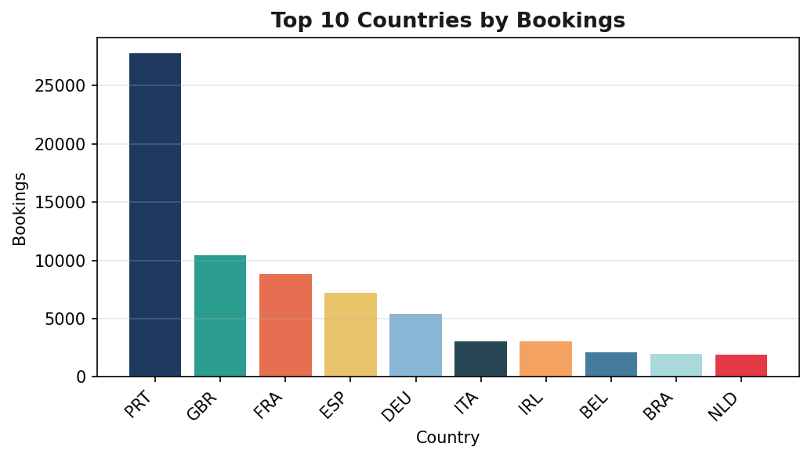
Figure 4.9 — Top 10 Countries by Booking Volume
Guests originating from PRT contribute the largest single share of bookings among all countries recorded, followed by a mix of other Western European source markets — indicating a geographically concentrated but still internationally diverse guest base.

5. Bivariate & Multivariate Analysis
This section examines relationships between pairs of variables — particularly how pricing (ADR) and cancellation behaviour relate to hotel type, guest composition, and booking channel.

5.1 ADR by Hotel Type
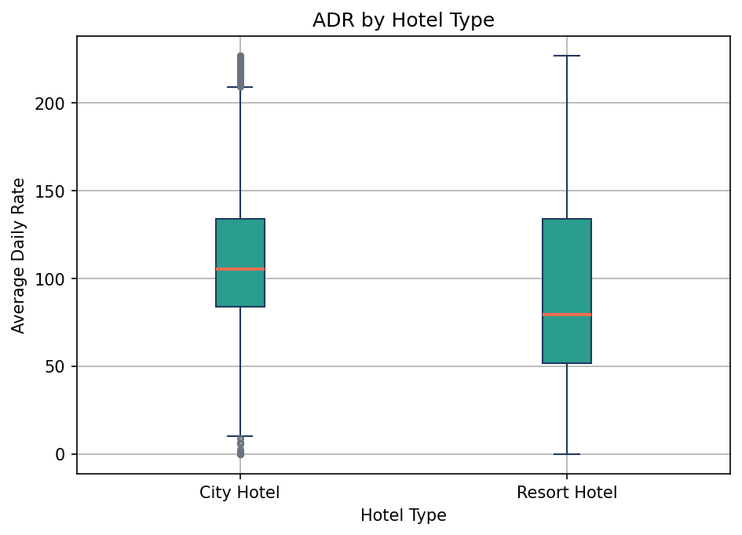
Figure 5.1 — ADR Distribution by Hotel Type (Box Plot)
City Hotel shows a higher median ADR (105.30) and a tighter interquartile range than Resort Hotel (median 79.66), while Resort Hotel exhibits a wider spread (std. dev 58.97 vs. 40.60 for City Hotel) — consistent with more seasonal, demand-driven pricing at resort properties. This gap is formally tested in Section 6.1.

5.2 Lead Time by Booking Status
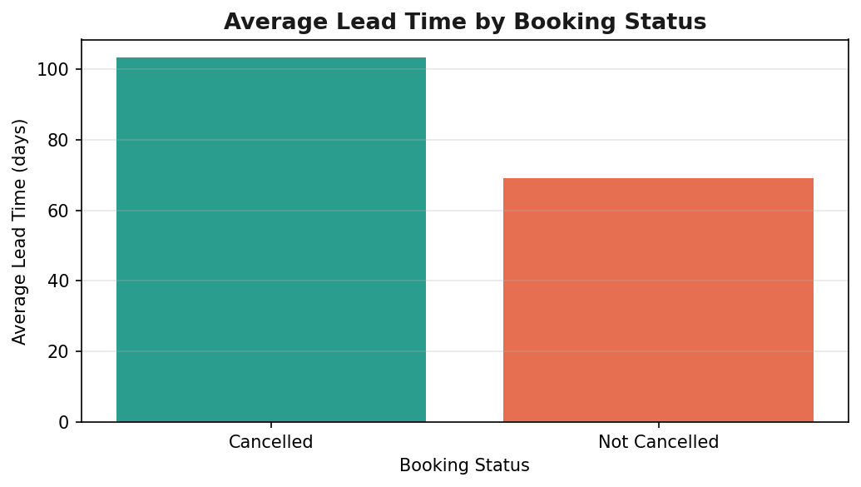
Figure 5.2 — Average Lead Time by Booking Status
Cancelled bookings have a notably longer average lead time (103.22 days) than completed bookings (69.06 days). This suggests that bookings made further in advance carry a higher risk of cancellation, plausibly because longer horizons give guests more opportunity for plans to change.

5.3 ADR vs Total Guests
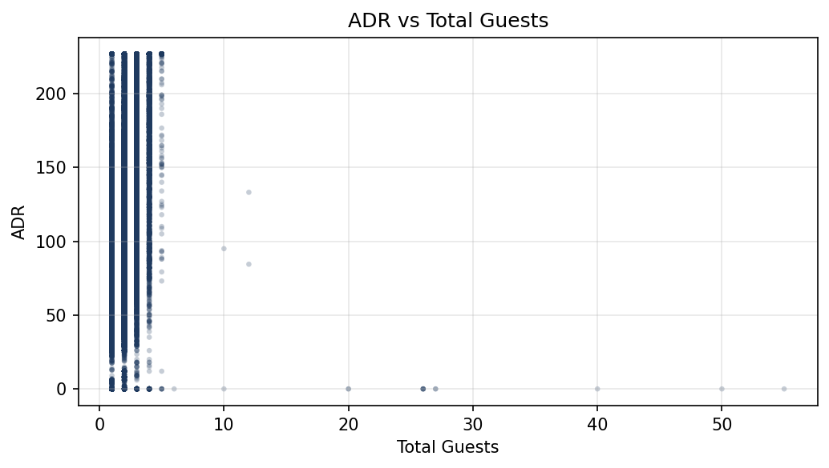
Figure 5.3 — ADR vs Total Guests
ADR rises with the number of guests (Pearson r = 0.398), a moderate positive relationship reflecting that larger parties typically book bigger or higher-tier rooms.

5.4 ADR vs Total Nights
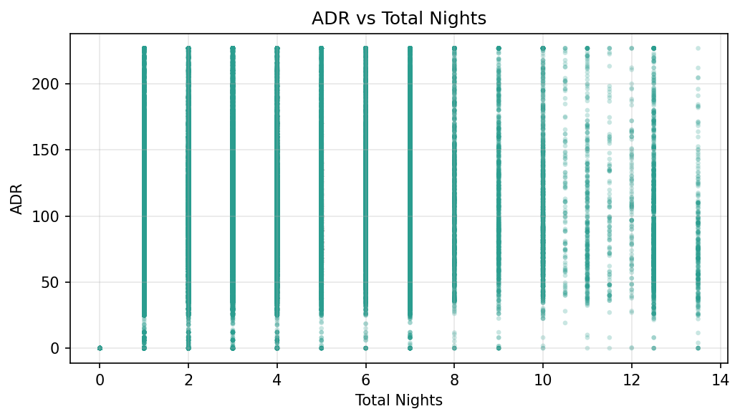
Figure 5.4 — ADR vs Total Nights
The relationship between ADR and stay length is weak (Pearson r = 0.077), indicating that nightly rate is largely independent of how long a guest stays — longer stays are not systematically discounted or upcharged in this dataset.

5.5 Average ADR by Market Segment
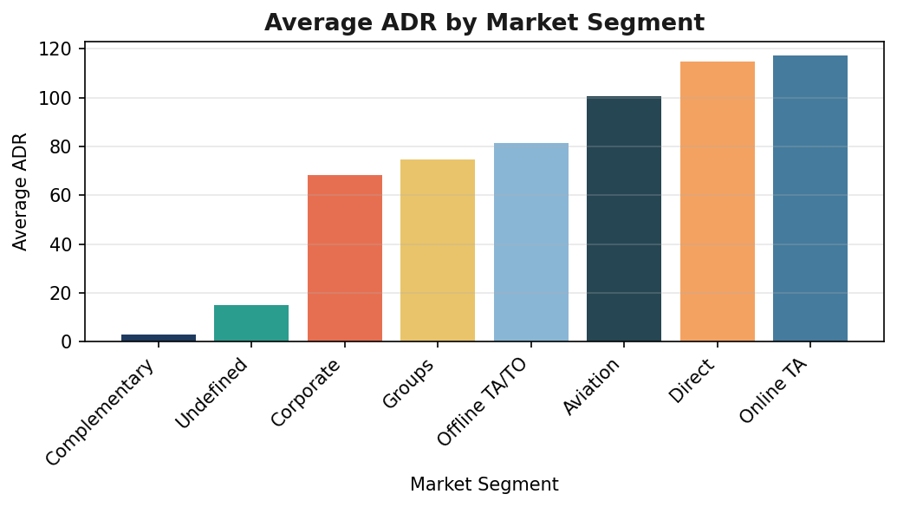
Figure 5.5 — Average ADR by Market Segment
Average ADR varies substantially by acquisition channel, from 3.09 for Complementary bookings up to 117.24 for Online TA bookings. Online TA and Direct channels command the highest average rates, while Complementary and Undefined segments — largely non-revenue or data-quality categories — sit at the bottom.

5.6 Average ADR by Customer Type
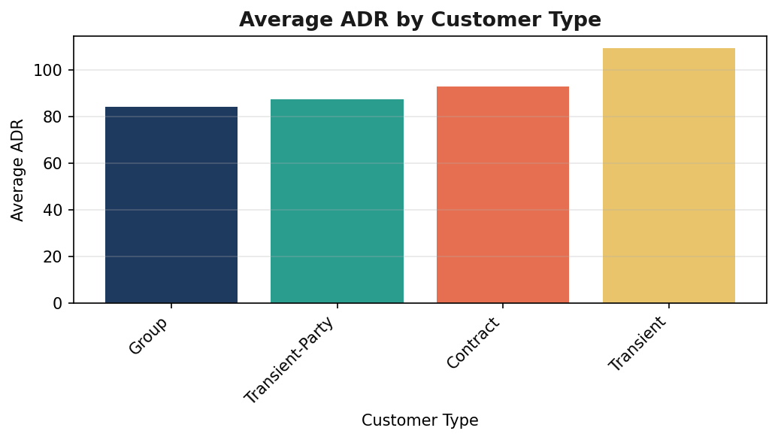
Figure 5.6 — Average ADR by Customer Type
Transient guests pay the highest average rate (109.18), while Group bookings pay the least (84.02) — an expected pattern given the volume discounts typically negotiated for group and contract business.

5.7 Cancellation by Hotel Type
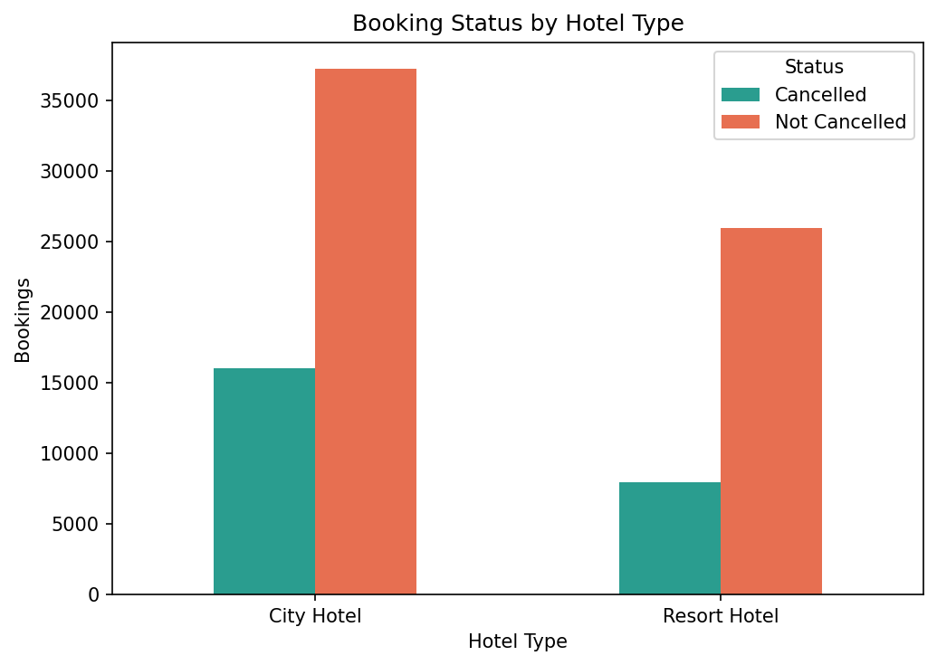
Figure 5.7 — Booking Status by Hotel Type
City Hotel has both a higher volume of cancellations and a higher cancellation rate (30.1%) than Resort Hotel (23.5%). This association between hotel type and cancellation outcome is tested formally with a Chi-square test in Section 6.2.

5.8 – 5.9 Correlation Analysis
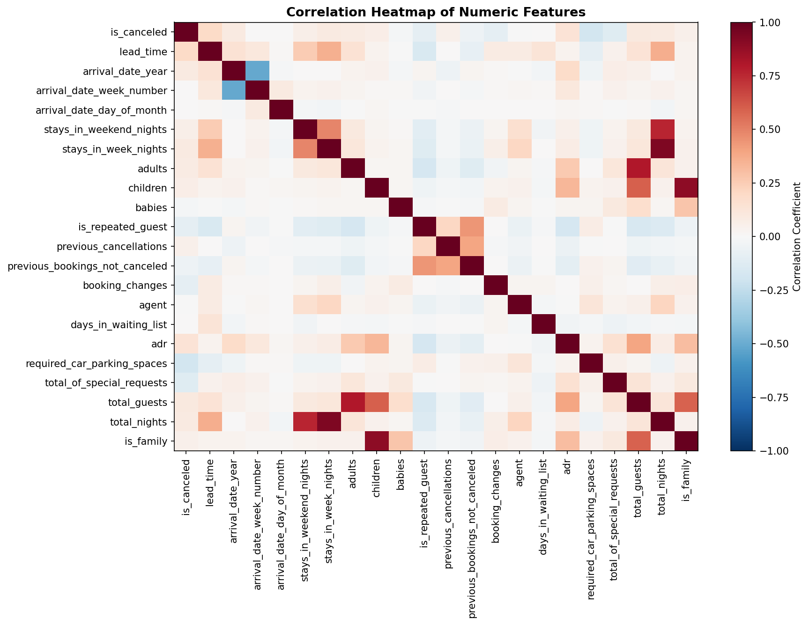
Figure 5.8 — Correlation Heatmap of Numeric Features
The correlation matrix highlights the strongest linear relationships in the dataset. ADR correlates most strongly with guest-count variables — total_guests (r = 0.398), children (r = 0.329), and is_family (r = 0.306) — confirming that party size and composition are the dominant pricing drivers among the numeric features. Cancellation (is_canceled) shows its strongest associations with lead_time (r = 0.188) and required_car_parking_spaces (r = -0.185, negative), suggesting that bookings made well in advance and bookings without a parking request are more prone to cancellation. All correlations in the matrix are modest in magnitude (|r| < 0.4), indicating no strong linear multicollinearity among the numeric predictors.

6. Hypothesis Testing
Two formal statistical tests were conducted to validate patterns observed in the visual analysis above.

6.1 Test 1 — Independent Samples t-Test: ADR by Hotel Type
- H₀ (Null): There is no difference in mean ADR between City Hotel and Resort Hotel.
- H₁ (Alternative): Mean ADR differs between City Hotel and Resort Hotel.

Statistic | Value
City Hotel — mean ADR (n) | 110.79 (n = 53,272)
Resort Hotel — mean ADR (n) | 97.28 (n = 33,931)
t-statistic | 36.957
p-value | < 0.0001
Table 6.1 — Welch's t-test results (unequal variances assumed)
Conclusion
With p < 0.0001 (well below the α = 0.05 threshold), the null hypothesis is rejected. There is a statistically significant difference in ADR between City Hotels (mean 110.79) and Resort Hotels (mean 97.28), confirming the pattern already visible in the Section 5.1 box plot.

6.2 Test 2 — Chi-Square Test of Independence: Hotel Type vs Booking Status
- H₀ (Null): Hotel type and booking cancellation are independent.
- H₁ (Alternative): Hotel type and booking cancellation are associated.

 | Cancelled | Not Cancelled
City Hotel | 16,035 | 37,237
Resort Hotel | 7,973 | 25,958
Table 6.2 — Observed contingency table: Hotel Type × Booking Status
Statistic | Value
Chi-square (χ²) | 452.580
Degrees of freedom | 1
p-value | < 0.0001
Table 6.3 — Chi-square test results
Conclusion
With p < 0.0001, the null hypothesis is rejected. Hotel type and cancellation status are statistically associated: City Hotel bookings are cancelled at a higher rate (30.1%) than Resort Hotel bookings (23.5%).

7. Key Findings & Recommendations

7.1 Key Findings
- City Hotel dominates booking volume (61.1% of all bookings) and commands a significantly higher ADR than Resort Hotel (p < 0.001).
- Overall cancellation rate is 28.0%, and cancellation is significantly associated with hotel type — City Hotel cancels more often (30.1%) than Resort Hotel (23.5%).
- Longer lead times correlate with a higher likelihood of cancellation: cancelled bookings average 103.22 days of lead time versus 69.06 for completed stays.
- Party size (total_guests, children, is_family) is the strongest numeric driver of ADR, while stay length (total_nights) has little bearing on nightly rate.
- Online Travel Agents are both the leading acquisition channel by volume and among the highest-ADR segments, alongside Direct bookings.
- Transient (individual) guests pay the highest average rates, while Group and Contract segments pay the least, reflecting typical negotiated-rate dynamics.

7.2 Recommendations
- Target retention and reconfirmation efforts (e.g. reminder emails, flexible-date offers) at bookings with long lead times, particularly for City Hotel, to reduce the elevated cancellation risk identified above.
- Review deposit-type policy alongside cancellation data — since the majority of bookings currently require no deposit, a partial-deposit requirement for high-risk segments (long lead time, Online TA) could be tested to reduce cancellation losses.
- Continue to prioritise investment in the Online TA and Direct channels, which combine high volume with strong ADR performance.
- Investigate resort pricing strategy further — the wider ADR spread at Resort Hotel suggests seasonal or event-driven pricing that may benefit from more granular time-series analysis in a follow-up study.

7.3 Conclusion
This EDA confirms two statistically significant relationships central to hotel revenue management: ADR differs meaningfully by hotel type, and cancellation likelihood is associated with both hotel type and lead time. Together with the descriptive and visual analysis of guest composition, channel mix, and pricing, these findings provide a solid evidence base for pricing, marketing, and cancellation-mitigation decisions going forward.

